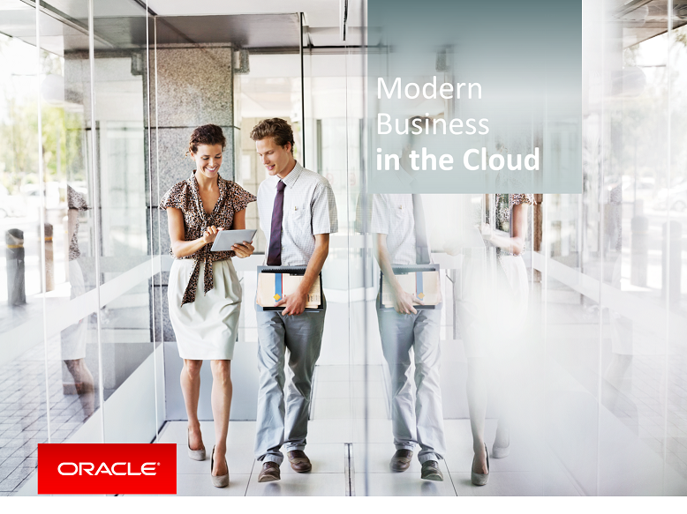

Oracle Content & Experience Cloud Service

Workshop

Chapter 1

Contents

Demo Attributes 2

Executive Summary 2

Storyline 3

Demo Flow 4

Part A: Login 4

Part B: Create a Channel & Repository for Assets 5

Part 3: Creating Assets 10

Part 4: Working with Assets – Content Types 14

Part 5: Working with Assets – Content Items 19

## Demo Attributes

|  |  |
| --- | --- |
| **Product(s)** | Content & Experience Cloud Service |
| **Date last updated** | September 2018 |
| **Author(s)** | Jens Lusebrink |
| **Demo Title(s)** | PaaS –Content & Experience Cloud Service (CEC) |

## Executive Summary

Oracle Content & Experience Cloud Service puts the power of creating highly engaging sites into the hands of non-technical line-of-business managers. A beautiful website built on collaborative content including images, PDFs, and presentations can be created in minutes. Applications and processes and can be integrated in as well. Assembling a web site is a matter of point-and-click

## Storyline

This HandsOn Lab will demonstrate how Oracle Content & Experience Cloud Service (CEC) provides a complete repository for Assets that can reused on web sites, online channels and connected applications like Oracle Marketing Cloud.

**End-to-End Application Flow**

This demo showcases the end to end flow of creating and assembling assets and associate them to Repositories:

* Create and classify assets
* Create repositories for distribution of assets
* Collaborate around asset creation with team members

## Demo Flow

| **S.No.** | **Action** | **Description** |
| --- | --- | --- |
| Part 1: Login | | |
| 1.01 | This is the main landing page for your cloud services  **Click** on Sign In to enter CEC | FOLLOW THE LINK IN YOUR ACCESS DOCUMENT  At the Login Prompt enter the user name and password that has been supplied to you. |

|  |  |  |
| --- | --- | --- |
| Part 2: Create a Channel & Repository for Assets | | |
|  | A publishing channel determines the release rules that are applied to an item in a repository. A channel can be public and available to everyone, or secure and limited. A repository can use multiple channels. You can select specific channels to use with specific assets in the repository, letting you decide the policies to be applied in individual cases.  You can manually create publishing channels and set specific policies for the channel and then share the channel with other people. | |
| 2.01 | This main CEC homepage has several features available depending on a user’s role.  For the HandsOn Lab (HOL) you will have the highest role available to do everything under one login.  We will focus on the Content and Asset part for this HOL | **Welcome to the Content & Experience Cloud Service Homepage.** |
| 2.02 | You need a lot of images and videos to create your customer experiences. Oracle Content and Experience Cloud helps you manage all your digital assets in repositories, where you can easily group and categorize them. You can also guide the creation and approval process, and define usage policies so digital assets are used only when ready and where allowed. | |
| 2.03 | Creating a Publishing Channel for your Assets | Publishing channels can be applied to a repository and then applied to all the assets managed in the repository.  A publishing channel determines the release rules that are applied to an item in a repository. A channel can be public and available to everyone, or secure and limited. A repository can use multiple channels. You can select specific channels to use with specific assets in the repository, letting you decide the policies to be applied in individual cases. |
| 2.04 | Creating ‘Publishing Channel’   1. Click on ‘Assets’ under the Administration section in the left hand panel 2. Select ‘Publishing Channels’ from the drop-down list. 3. You’ll see a list of Publishing Channels available depending on your cloud environment. 4. Click on ‘Create’ to create a new Publishing Channel 5. Fill the form: **Name**: My*_username_*channel **Description**: whatever you like 6. For the Publishing Policies: Access: PUBLIC Publishing: Anything can be published Localization: None 7. Click on ‘Save’ |  |
| 2.05 | You have successfully created a Publishing Channel. The next step will be the creation of a Repository and assign the Publishing Channel to it. | |
|  | Creating an Asset Repository | Repositories are a storage location for files, both text and images. Repository administrators can create a repository with channel policies and localization policies designated for the repository. Multiple repositories can be created to handle all your marketing needs.  A repository can be used to manage all the assets you need in one place. For example, perhaps your company sells computer equipment. One repository could be set up to handle the files related to desktop computers. Another repository could be used for tablets. Each repository might contain photos, graphics, and content about the different kinds of computers. The assets in each repository are controlled by the policies you allocate to the repository. You need the repository administrator role in order to create policies and repositories. |
| 2.06 | Creating Asset Repository   1. Click on ‘Assets’ under the Administration section in the left hand panel 2. Select ‘Repository from the drop-down list. 3. You’ll see a list of existing Repositories available depending on your cloud environment. 4. Click on ‘Create’ to create a new Repository |  |
| 2.07 | 1. Fill the form: **Name**: My_*username*_repo **Description**: *whatever you like* 2. Select the Publishing Channel you have created earlier from the drop-down list. 3. Click on ‘Save’   **NOTE: Leave all other fields blank or with their default values**. |  |
|  | **Congratulation** | |

|  |  |  |
| --- | --- | --- |
| Part 3: Creating Assets | | |
| 3.00 | Enterprise users have access to digital assets: images, videos, and content items that can be used in websites, in publications, or in other marketing and media channels. They can group, tag, and manage all the assets that are used for specific purposes, like in a website, marketing campaign, or for a particular project. | |
| 3.01 | Assets are stored in Content Repositories. We will now create some assets and store them in the repository we just have created.   1. Click ‘Assets’ in the left hand pane. 2. Select your *username* repository from the drop-down list   You’ll notice that you don’t have any assets currently. We will now create some.   1. Click on ‘Add’ in the blue menu bar 2. This will lead you to the ‘Document’ repository’ you have working in part 1 of the HOL. 3. Open the folder ‘Images’ and select the first ‘tick box’ to select all images in this folder. 4. Click on ‘OK’ to associate these images to your Asset Repository 5. On the confirmation screen, leave the values for ‘Collections’ and ‘Targeted Channels’ blank and click ‘Add’. 6. You will see a progress window. 7. Once the process has finished, leave the window by clicking on ‘Close’ 8. Now you see all assets in your selected Repository. |  |
|  | **Congratulation**, we are now done with creating assets for our CEC repository.  You have learned how to select and idetify assets and assign them to a repository. | |

|  |  |  |
| --- | --- | --- |
| Part 4: Working with Assets – Content Types | | |
| 4.00 | Next, we are creating a **Content Type and Content Item**. A content type is a framework used to specify what information is included in a content item. Content items are created using a content type as a form or template. | |
| 4.01 | First, we will work in the Administration / Assets part again to create a Content Type and associate it to our Repository   1. Go to Administration | Assets 2. Select ‘Content Type from the drop down list. 3. On the following page select ‘Create’ to start creating your Content Type. 4. Provide a name prefixed with your username and a description. The name should give some indicator what the Content Type will represent on the page. 5. Click ‘OK’ |  |
| 4.02 | The Content Type will be created in the background and you will see the definition form.   1. Drag and drop the ‘Media’ field from left to right. 2. Once you dropped the media field on the right, a Settings window will pop up.   Here you define the properties for the Type ‘Media’ in your Content Type. You can select between various options. Please follow the screenshots.   1. Click ‘Next’ if you have completed the 1st page. 2. Deselect Documents on the 2nd page. 3. Click ‘OK’ |  |
| 4.03 | Next, we want to create a placeholder for a text in our Content Type.   1. Select the ‘Text’ element and drop it onto the right **under** the Image. 2. In the pop up   Please follow the screenshots.   1. Click ‘Next’ if you have completed the 1st page. 2. Click ‘OK’ |  |
| 4.04 | Finishing the Content Type creation. By now we have created our Content. Type.  To save the Content Type, click ‘Save’ on the top right menu. |  |
| 4.05 | We have created a Content Type layout (tempate) that we can use in the next step to create Content Items based on this layout. | |
|  |  |  |
| 4.06 | Content Types must be associated to a repository and a publishing channels in order to make them available.   1. On the ‘Administration | Assets’ overview page select ‘Repositories 2. .From the list of Repositories, select yours and 3. Click ‘Edit’ 4. The repository details are displayed and you can select which Content Type you would like to assign to this repository. 5. Click into the line under the Content Types header and select your Content Type. 6. Leave all other settings untouched. 7. Click ‘Save’ on the upper right menu. |  |
| 4.07 | You have assigned your Contet Type to a repository. | |
| Part 5: Working with Assets – Content Items | | |
| 5.00 | Now that we have created a Content Type we will actually create Content based on our Content Type template- | |
| 5.01 | We will go back to the Assets menu in our navigation.   1. Click on ‘Assets’ 2. Click ‘Create’ in the upper right menu and select ‘Create a new Content Item’ from the drop-down. 3. In the new pop-up, select your Content Type from the previous exercise. 4. Provide a name and description. 5. Under Targeted Channels, select your Channel from the previous exercise. 6. Leave everything else a default 7. Click ‘OK’ to finish. |  |
| 5.02 | You now see the Content Type layout with all the fields we have created earlier.   1. Select an image from our Assets repository. 2. Click on ‘Select’ 3. In the selection dialog, scroll down until you see the ‘Profile_Header’ image or enter ‘Profile’ into the search bar and hit ‘Find’ 4. Select the image and click ‘OK’ 5. Accordingly, enter some text into the text box. 6. Finally, click ‘Save’ on the upper right menu. 7. Then click ‘Close’ to leave the page. |  |
| 5.03 | 1. Back on the Assets view, select ‘Content Items | *Your_name* 2. The ‘circle’ indicates that it is currently in draft mode and not available for use. 3. Select your item and notice that the top menu offers ‘Submit for Review’ 4. Click on ‘Submit for Review’ |  |
| 5.04 | 1. Back on the Assets overview page, select ‘In Review’ from the Status list. 2. Your Asset should appear with an updated marker. 3. Again, mark your Asset and click on ‘Approve’ to finally approve your asset and make it available. |  |
| 5.05 | Before we are able to use our asset on e.g. a website, we have to assign it to a Publishing Channel.   1. Select your asset and click on ‘Publish’.   Remember, we have created a Publishing Channel earlier and assigned it to our Repository.   1. In the pop-up window, the channel and content item are already linked. 2. Click on Publish to finish this step. 3. Back ono the Assets screen, you notice that the status icon for your content item has changed again. |  |
|  | **Congratulation**, we are now done with cerating Assets.  You have learned how to create and assign assets. | |